**SubNet Document:**

**Defalut SubNet Masks:**

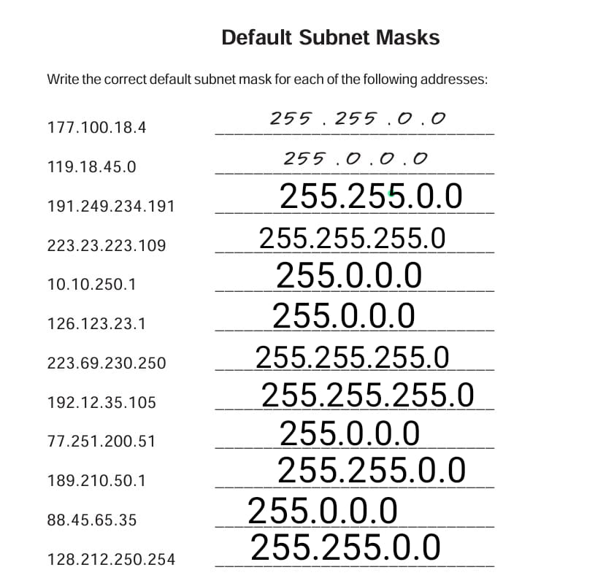

**IP Address Host:**

**Binary To Decimal Conversation:**

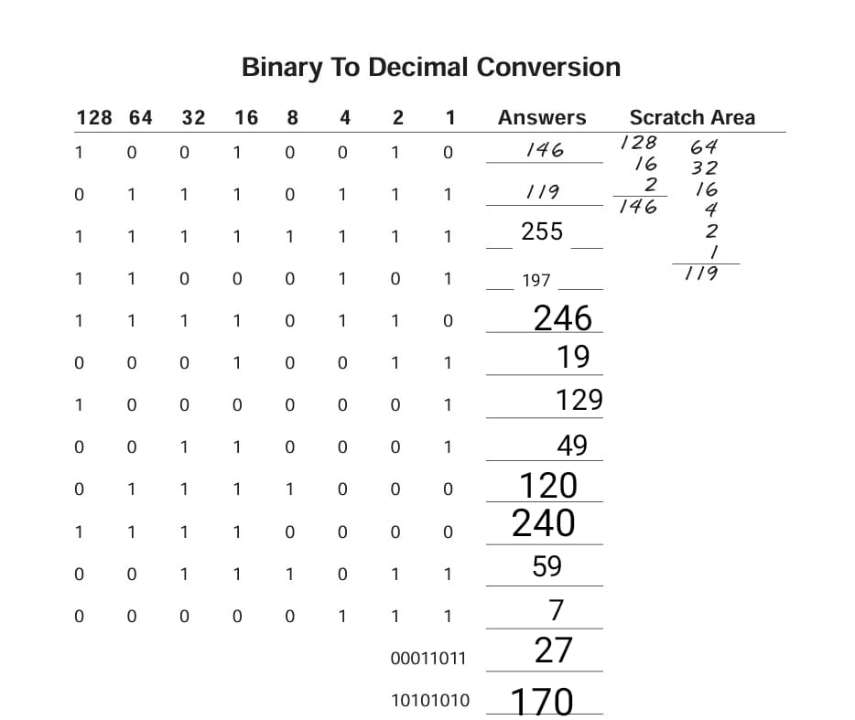

**Network Address:**

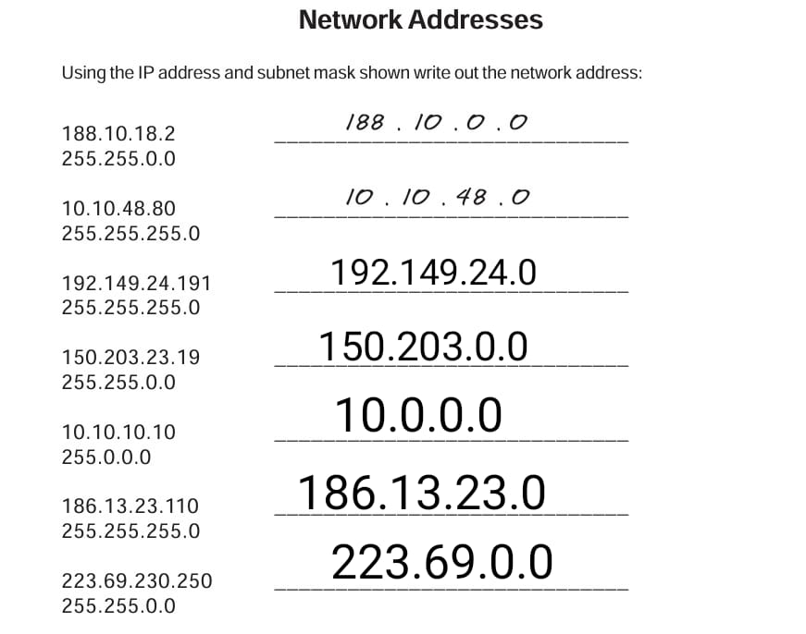

**Decimal To Binary:**

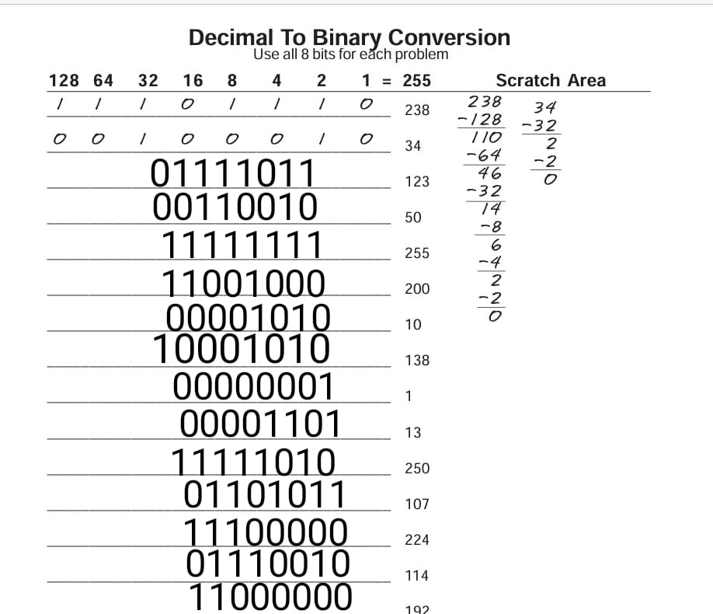

**Class Address Identification:**

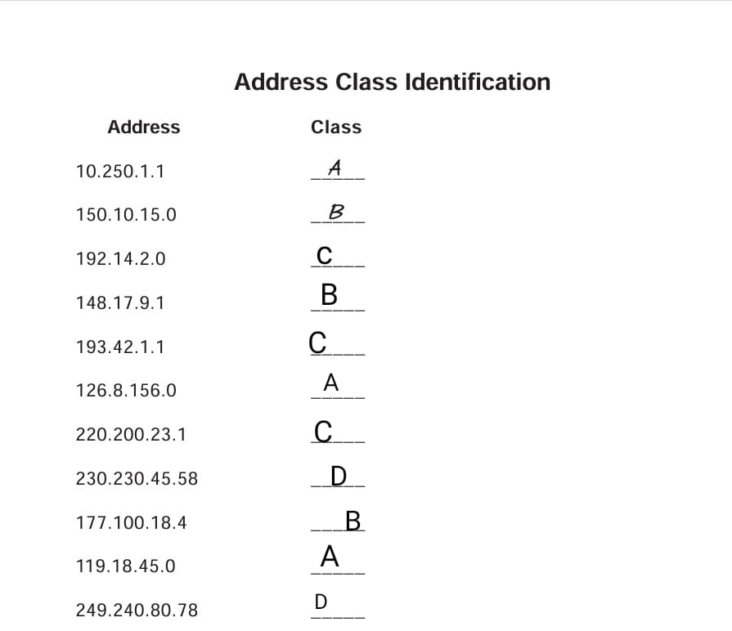

**Host Addresses:**

